Flowlet

Flowlet works as function for data flow

Instead of creating multiple dataflows create one and use it as function and give parmeter

1. Go to dataflow in author and select new flowlet

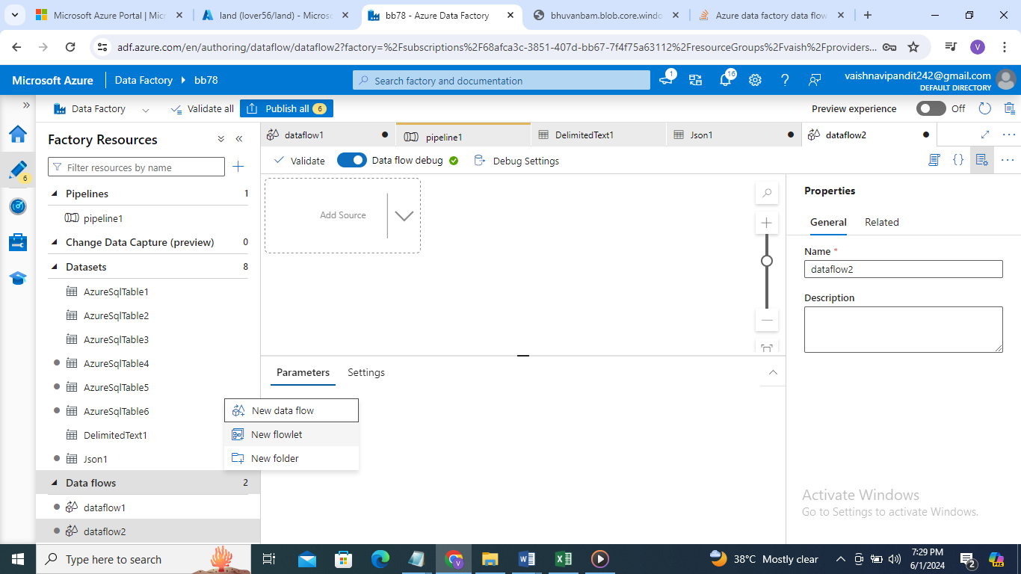

1. Now go to flowlet

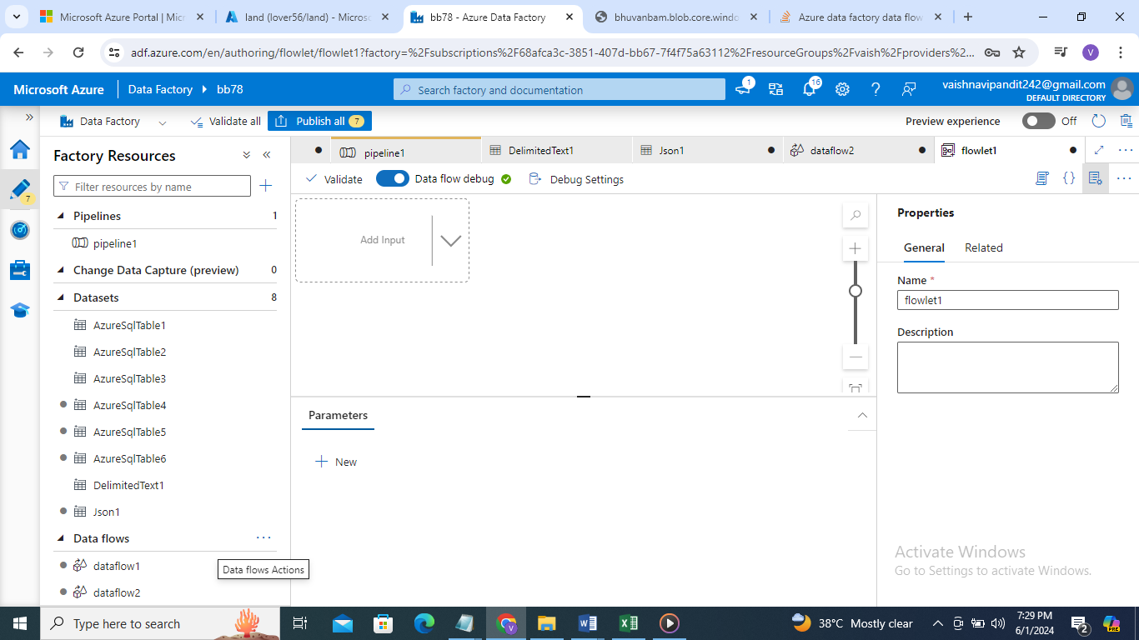

1. Add input

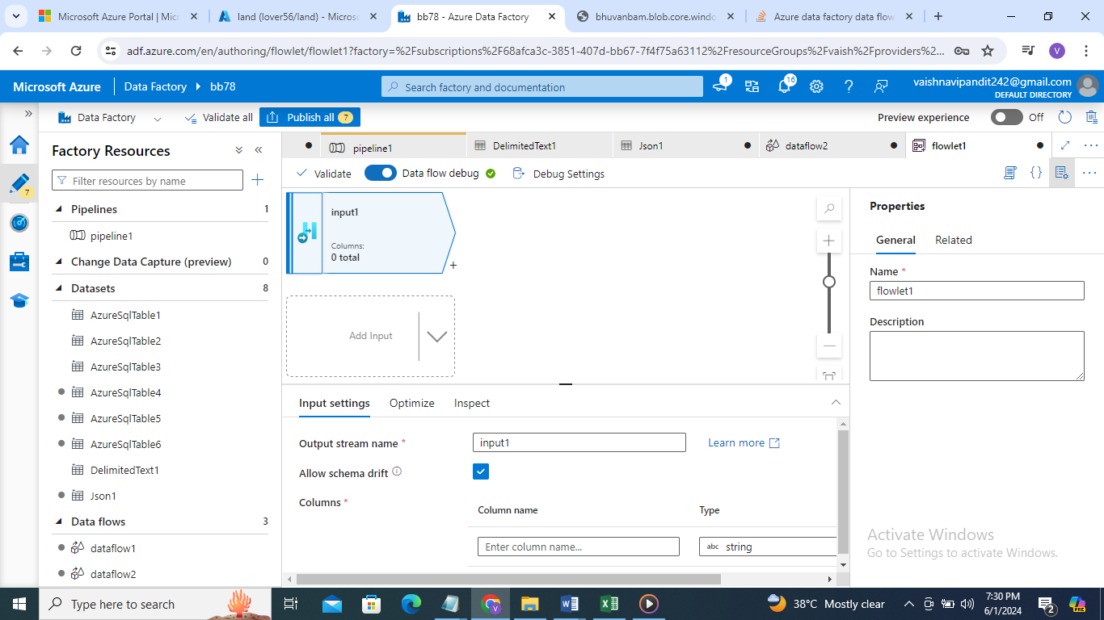

1. Go to input

Add columns id , name

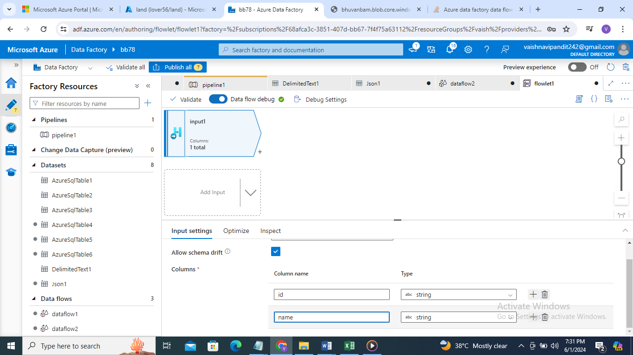

1. Click on + add aggregate

In group by select id

And in aggregate cnt add count()

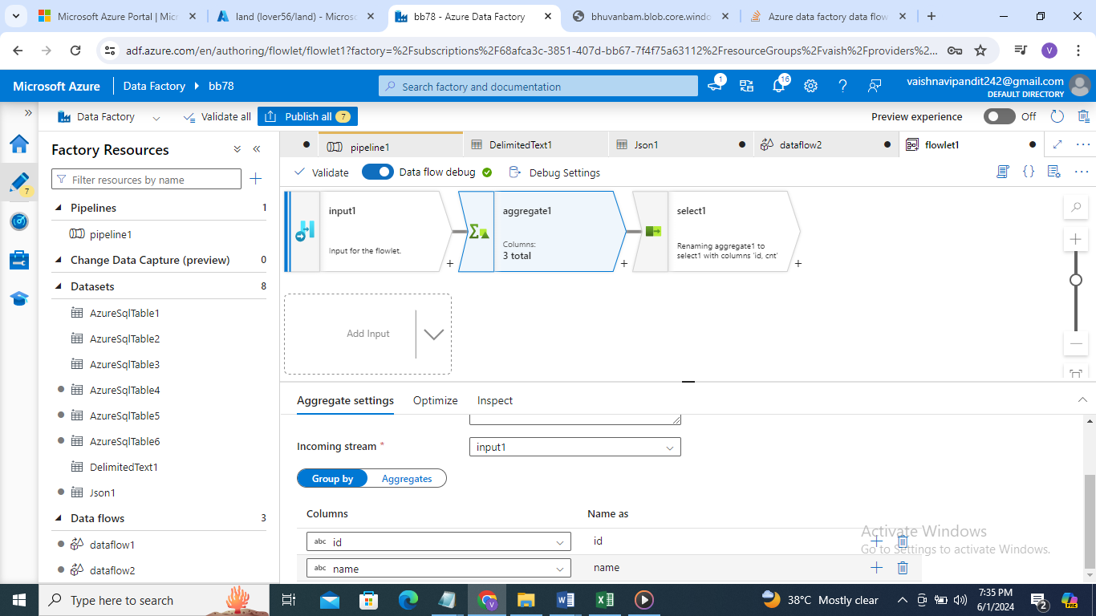

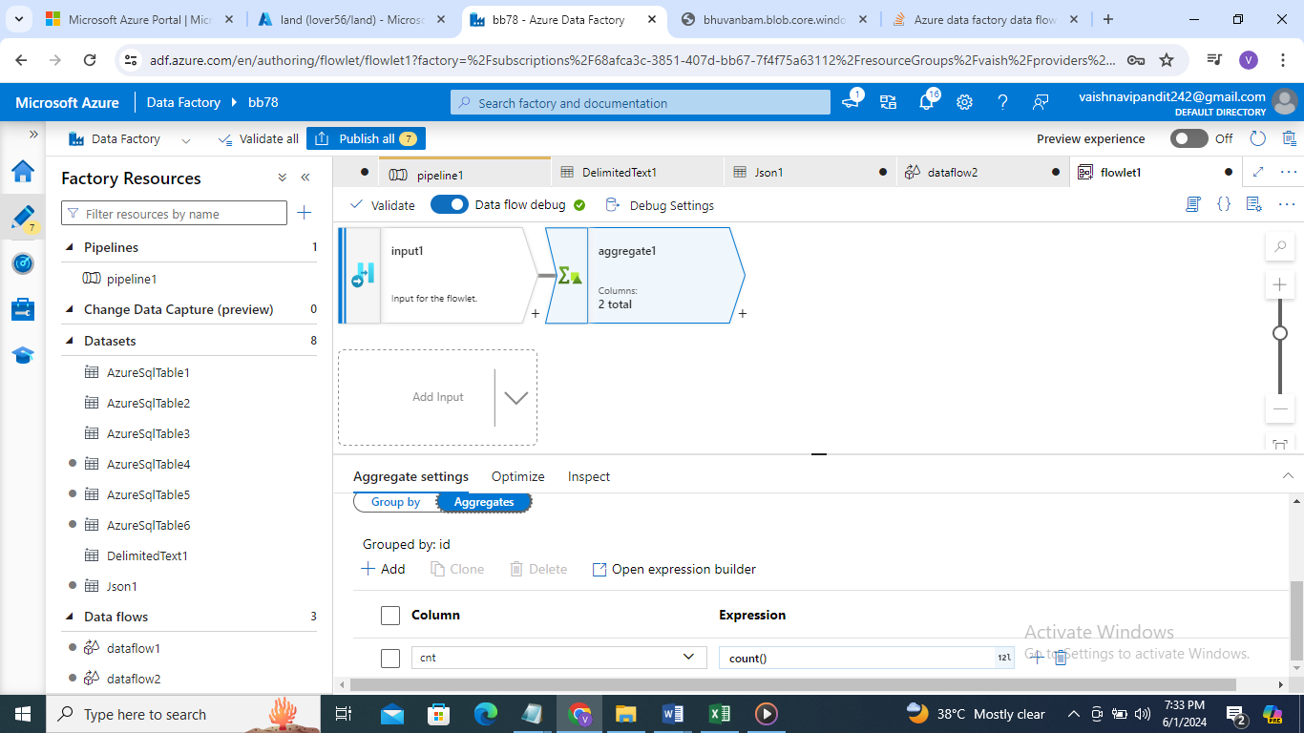

1. Now create select to select id, name

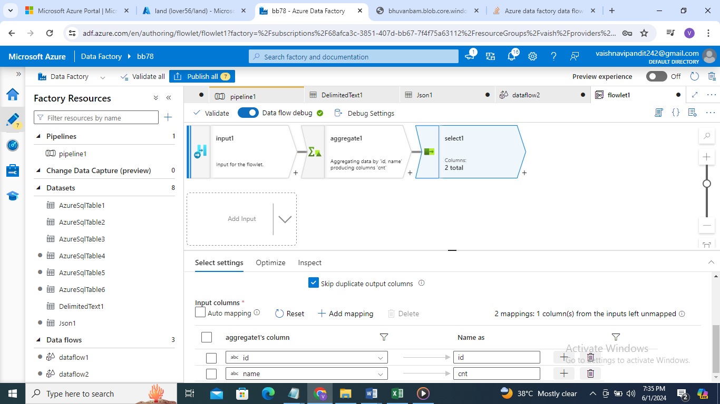

1. Now slect output in plus

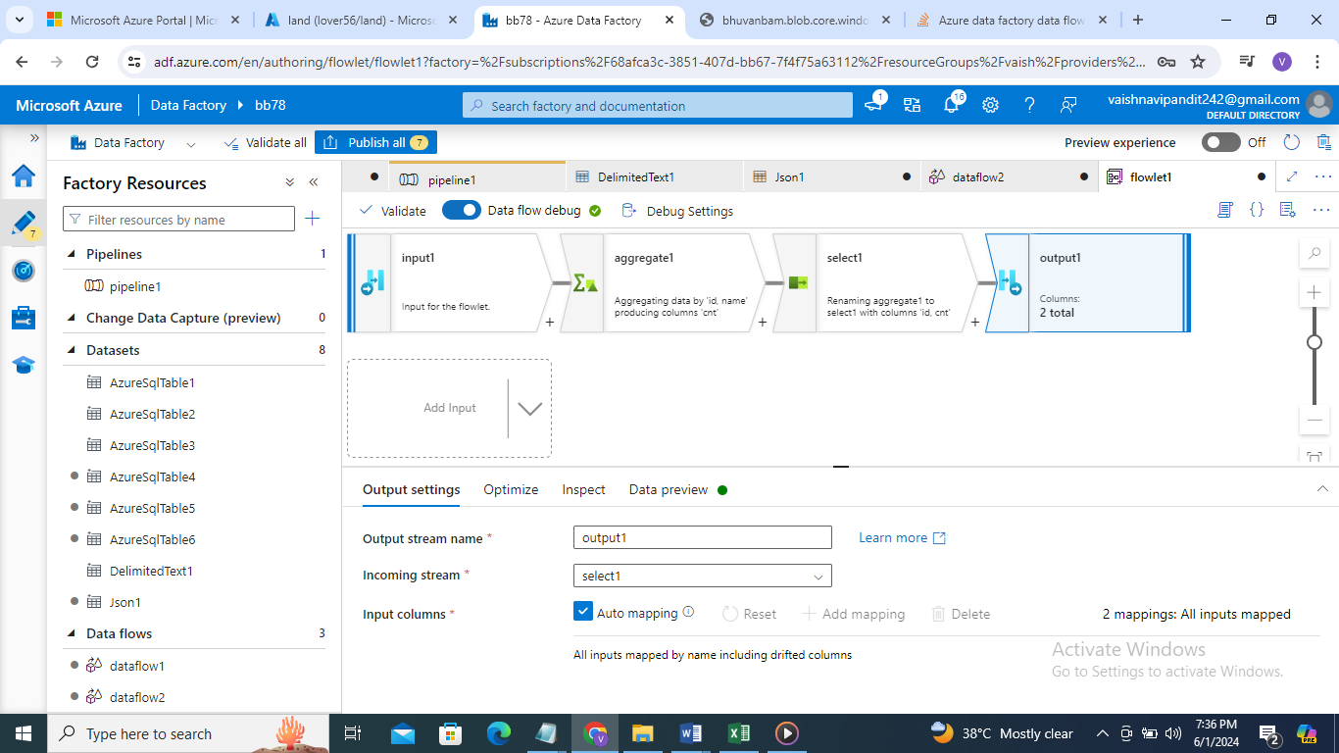

1. Now create dataflow add two sources for two datasets employee and department

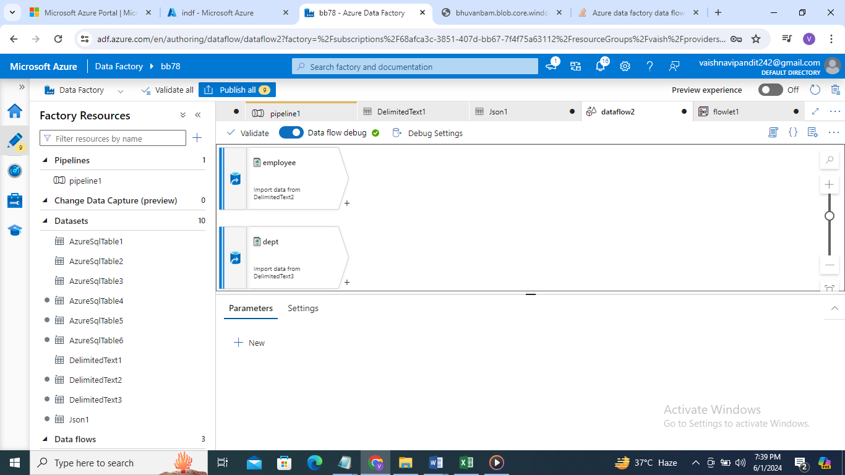

1. Now add flowlet to both

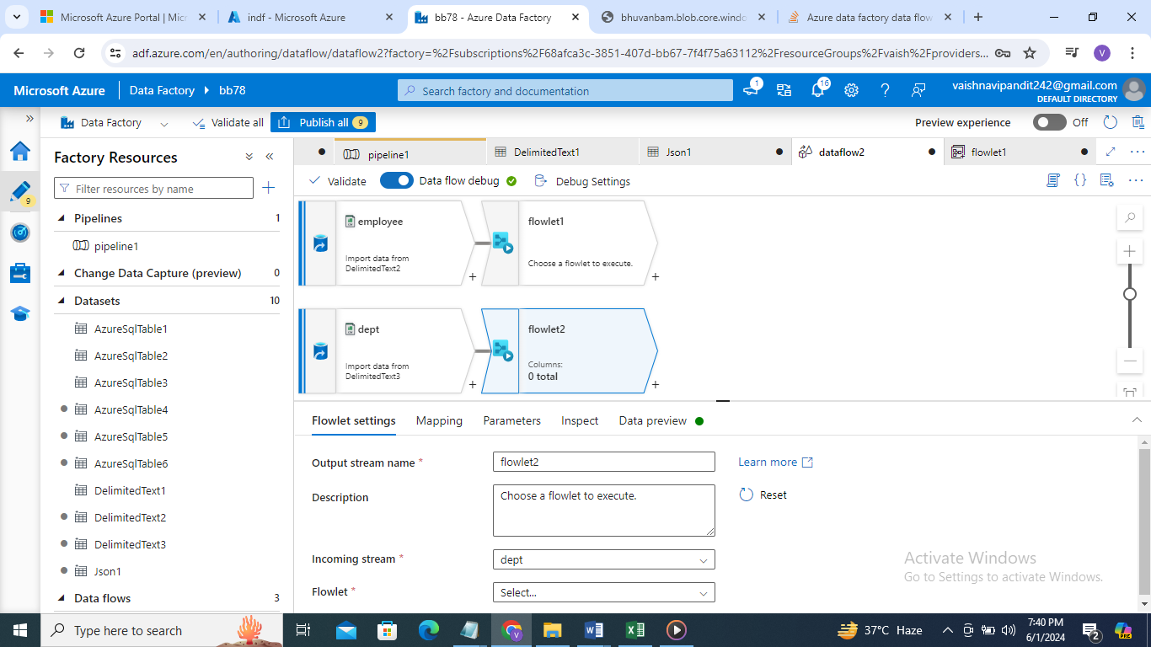

1. Go to flowlet

Add flowlet created go to mapping and select parameter to represent

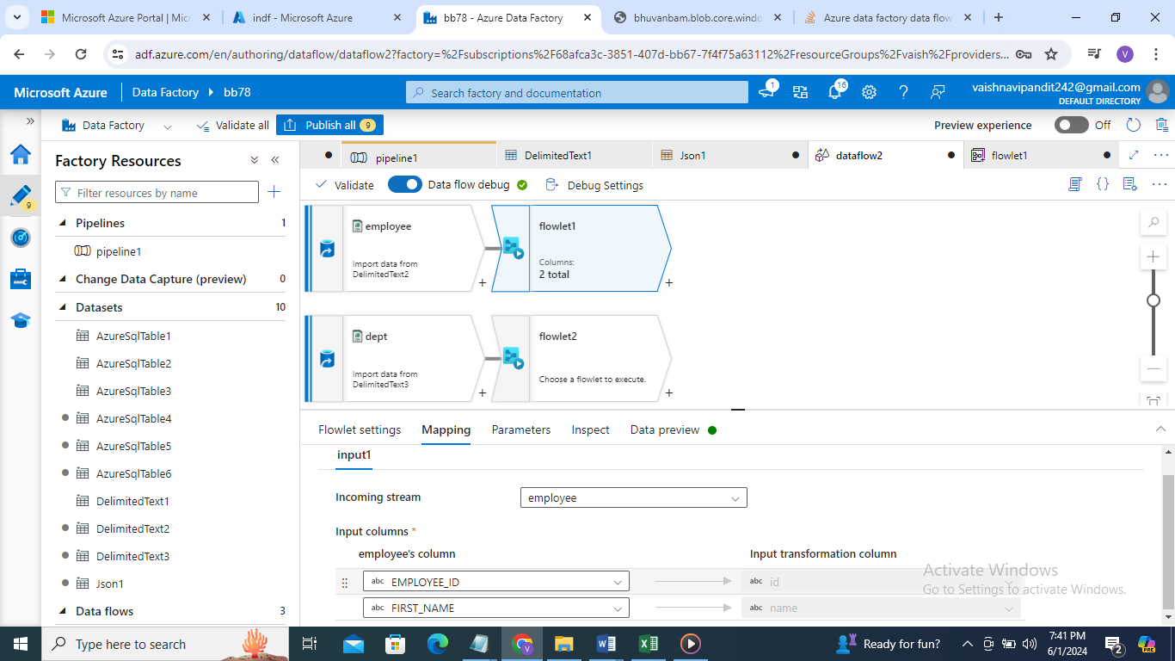

1. Similarly do for flowlet 2 now both dep and employee table will get highest 2nd count data